Appendix 3 - LCC Education statutory consultee response to the Lanes planning application 07/2021/00886/ORM
We have been reviewing the email response from the LCC Schools Planning group dated 8th October 2021 and the accompanying Education Contribution Assessment dated 17th September 2021.
We have a number of queries relating to the demand for primary school places arising from committed developments in the vicinity of the proposed site, and from the two planning applications 07/2021/00886/ORM and 07/2021/00887/ORM.
We have similar concerns regarding Secondary and Pre-school education provision.
- Background information
The committed developments considered to impact the proposed development are listed below. They were used in the transport assessment completed by Vectos
Committed developments employed in the Vectos TA
ID | Name | Dwellings | Employment space m2
1 | Croston Road | 174 (350) | N/A
2 | Croston Road North | 400 | N/A
3 | Penwortham Mills | 385 | N/A
4 | Gas Works | 248 (281) | N/A
5 | Cuerden | 210 | 205,600
6 | Test track | 950 | 28,000

Q1 Can LCC please confirm which of the committed developments listed above have been employed to predict the demand for primary and schools in the proposed development catchment?
Q2 under the section “Pupil Yield” there is reference made to a “detailed research project carried out during 2012” through which pupil yield is calculated for a bedroom mix within a development. Could LCC please provide a copy of this research paper?
- Assessment of Primary School Pupil Yield
LCC state that as the developer has not provided bedroom numbers for the development LCC apply a pupil yield appropriate for a four-bedroom development.
The yield data employed for the four-bedroom case is given below and extracted from the Education Contribution Assessment document.
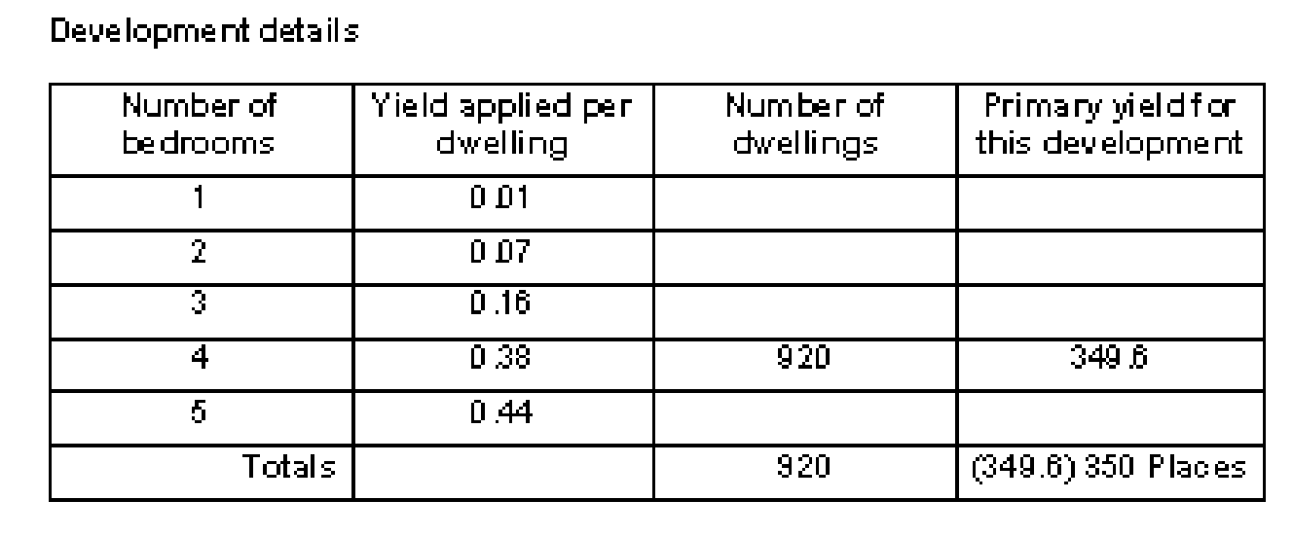
As part of our research on the subject of new development population demographics we have found a number of useful references including this one;
“Population Forecasting Study; Cognisant research for Northamptonshire County Council 2014.”
This was a comprehensive survey-based research project with 2,985 addresses in new developments chosen at random using a mix of face to face interview and postal questionnaire to obtain the required information. The intent of the research was to establish robust Pupil Product Ratios (PPR’s) in order to yield accurate numbers of school age children generated by a new housing development.
As a result of that research data has been produced on how many school age children are resident in a new development dwelling as a function of bedroom number and also how the provision of social or affordable housing changes this metric.
Cognisant research study; Children by age distribution as a function of bedroom number
Number of bedrooms in dwelling | 1 | 2 | 3 | 4
Pre School Children | 0 | 0.30 | 0.32 | 0.34
Primary School Children | 0 | 0.13 | 0.32 | 0.37
Secondary School Children | 0 | 0.03 | 0.17 | 0.22
Post 16’s | 0 | 0.03 | 0.07 | 0.09

Cognisant research study; Children by age distribution as a function of bedroom number for social housing
Number of bedrooms in dwelling | 1 | 2 | 3 | 4
Pre School Children | 0 | 0.52 | 0.63 | 0.92
Primary School Children | 0 | 0.19 | 0.83 | 0.58
Secondary School Children | 0 | 0.04 | 0.41 | 1.00
Post 16’s | 0 | 0.05 | 0.19 | 0.58

As LCC are aware the application includes for the provision of 30% affordable homes. Using a suitably weighted “yield” to account for affordable homes given in the Cognisant research the following adjusted yield is apparent. 0.7 x 0.38 + 0.3 x 0.58 = 0.44.
As LCC are aware the total number of homes from the two planning applications is 1,100.
Therefore, the total yield of primary school children accounting for the provision of 30% affordable housing and assumption of 100% four-bedroom homes is 484 not 350.
It should also be noted that from the Cognisant research the maximum “yield” of primary school children actually occurs in three-bedroom homes. The assertion made in the LCC response that the choice of four bedrooms for the analysis presents a worst-case scenario is not true according to the Cognisant research.
In fact, if a more realistic assumption of 10 % two bedroom, 50% three bedroom and 40% four-bedroom split is made for the development, the population of primary school children for the 1100 home Lanes development increases to 523. This is significantly higher that the estimate made in your response.
Q3 In the light of our findings are LCC prepared to reconsider the response that appears to seriously underestimate primary school demand from the development by neglecting the impact of affordable housing.
• Dependent Development; Impact on primary School places
Your response identifies 26 primary school places taken by dependent developments. We are concerned that many of the primary schools listed in the response are in fact closer to a large 600+ home committed development being built off Flensburg Way/Croston Road and to a committed housing development at Penwortham Mills at 633 homes, than they are to the development site access road. It is also worth noting that the Test Track housing development at 950 homes is only located 2.5 miles from the proposed site entrance.
In addition, there are many small committed housing developments, 127 in total, in the area of Hutton, Hoole, Longton, New Longton and Howick parishes that will also be competing for primary school places. They do not appear to feature in the list of approved or pending housing developments given in the response the committed developments are identified in the SRBC Housing Position Statement 2020.
These committed developments provide the potential for (600 + 633 +127) x 0.38 primary school children = 517.
Of the fifteen listed primary schools at least five are closer to large committed developments than to the development site so to take a prudent position this dependent development demand is reduced to one third e.g. 172 primary places
It is difficult to reconcile your figure of 26 primary places from dependent developments with the figure of 172 calculated above.
Q4 Given the demand for primary school places from committed developments in the catchment area of many of the primary schools listed, are LCC prepared to reconsider the response that appears to seriously underestimate primary school demand from committed developments?
- The impact of Population demographics in South Ribble and Preston.
In your response it is argued that population data from the region indicates that for many of the primary schools listed pupil numbers decline in 2026 relative to the current roll.
We are struggling to reconcile this assumption with recent housing market assessments such as “Central Lancashire Strategic Market Assessment” by GL Hearn dated September 2017 which concludes that the population of South Ribble and Preston will grow by 2.9% and 3.1% respectively between 2014 and 2034. The Central Lancashire Housing study by Iceni dated October 2019 also indicates that household growth in South Ribble will increase by 3.3% from 2019 to 2029.
Q5 Given this data from two recent housing studies based on regional demographics are LCC prepared to reconsider the response that appears to contradict the findings of these studies by significantly reducing pupil numbers for many primary schools listed from current to 2026?
- Conclusion
Our analysis indicates a serious shortfall in primary school places.
3985 places available as a result of school expansion
3698 roll number by assuming population of primary school children does not change (conservative)
Leaving a capacity of 287 places
Assume 172 primary places taken by local committed developments (conservative)
Leaves a total of 115 places available for the Lanes development
523 places required by the Lanes at 1100 homes and 30% affordable housing
Shortfall of 408 primary places.
This indicates that there may be a serious issue developing and we think this merits a thorough and comprehensive review, as the implications of getting this analysis wrong are profound.

